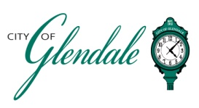
NOTICE OF PUBLIC MEETING
TUESDAY, MARCH 4, 2025 – 1:00 P.M.
TREE BOARD MEETING
AGENDA

- MEETING CALLED TO ORDER

- ROLL CALL

- CITIZEN COMMENTS

- PLANNING FOR 2025 ARBOR DAY EVENT

- 50/50 TREE PROGRAM

- MISCELLANEOUS BUSINESS

- REPORTS

- ADJOURNMENT

________________________
Frank Johnson
City Administrator/City Clerk Posted 3:00 PM, MARCH 3, 2025

